PSSI Science Project Reporting Template

️ | The PSSI Implementation Team is compiling a technical report to demonstrate the important research and advancements made by the Science Branch through the PSSI funding. The technical report will include a 3-4 page summary (including graphics and figures) for each project to show their key results and findings. Please fill in the following fields and sections for your project to be included in the report. Feel free to include and draw from any reports or presentations previously created through your research.  A plain language science bulletin will also be created to follow up on last year’s “DFO Pacific Region Science Bulletin, 2024. New research and monitoring for Pacific salmon and their ecosystems.” While the first bulletin introduced project backgrounds, methods, and timelines, this new bulletin will highlight the projects’ results, key findings, and conclusions with links to reports and data available. The bulletin will include a 1-2 page summary for each project gleaned from the content entered below.  ️ Completed forms are due January 7, 2026.  *Please include or send separately any graphics or pictures (with photo credits) that will help promote the projects.

PART 1: PROJECT METADATA

General Project Information
Project ID (number) | Project Title
2413 | Barkley Sound and Clayoquot Sound Krill Monitoring
Project Leads | Collaborations and External Partners
Akash Sastri, Kelly Young | - PSSI project, “Follow the Fish” co-investigators  - University of British Columbia, Prof. Rich Pawlowicz (Physical Oceanography)  - Bamfield Marine Science Centre  - Ha’oom Fisheries Society
Location (if applicable)
Barkley Sound
Clayoquot Sound

Geographic and Stock Information
Salmon species (if applicable) | Waterbodies (if applicable)
WCVI Chinook, Coho | Barkley Sound  Clayoquot Sound
Life history phases (if applicable) | Region
First marine year | West Coast Vancouver Island
Stock (if applicable) | Population (if applicable)
Click or tap here to enter text. | Click or tap here to enter text.
Conservation Unit (if applicable)
Click or tap here to enter text.

🧰 PART 2: PROJECT METRICS

Project Outputs
Include any anticipated outputs denoted as (in progress). Please include links to any outputs available online so they can be referenced in the report.
List scientific publications and technical reports (with links)
Technical publications:

Young, K., Galbraith, M., Hennekes, M., Hirst, A., Kafrissen, A., and Sastri, A. Barkley Sound Euphausiid monitoring project. In Boldt, J.L., Joyce, E., Tucker, S., Gauthier, S., and Jackson, J. (Eds.). 2025. State of the physical, biological and selected fishery resources of Pacific Canadian marine ecosystems in 2024. Can. Tech. Rep. Fish. Aquat. Sci. 3687: viii + 337 p. https://doi.org/10.60825/hxdg-q818

Young et al. Physical, Chemical and Biological Data Collected from the DFO-PSSI Barkley Sound Euphausiid Monitoring Project, 2022. Canadian Data Report (in progress)

Young et al. Physical, Chemical and Biological Data Collected from the DFO-PSSI Barkley Sound Euphausiid Monitoring Project, 2023. Canadian Data Report (in progress)

Young et al. Physical, Chemical and Biological Data Collected from the DFO-PSSI Barkley Sound Euphausiid Monitoring Project, 2024. Canadian Data Report (in progress)

Young et al. Physical, Chemical and Biological Data Collected from the DFO-PSSI Barkley Sound Euphausiid Monitoring Project, 2025. Canadian Data Report (in progress)

Anticipated primary publications:

Sastri et al. Interannual and seasonal variation of biomass and phenology of dominant euphausiid species in Barkley Sound, 2022-2025. In preparation for primary publication (in progress)

Sastri et al. Interannual and seasonal variation of lipid, protein, and caloric content of zooplankton in Barkley Sound, British Columbia, Canada. In preparation for primary publication (in progress)

List datasets generated (with links)
Water properties (physical: 2022-2025). CTD: posted incrementally on WaterProperties.ca following data QA/QC. www.waterproperties.ca/data

Water properties (chemical: 2022-2025). Nutrients, Chlorophyll a: posted incrementally on WaterProperties.ca following data QA/QC.

Phytoplankton taxonomy, abundance, and biomass. IOS Phytoplankton Database. Curation for forthcoming posting on open.canada.ca

Zooplankton taxonomy, abundance, and biomass. IOS Zooplankton Database. Curation for forthcoming posting on open.canada.ca

Describe dataset locations and data management systems
IOS Zooplankton Database (available upon request)
IOS Phytoplankton Database (available upon request)
Water Properties website (www.waterproperties.ca/data)
List code, programs, or other software created (with links)
Click or tap here to enter text.
List communication or social media products
Click or tap here to enter text.
List and describe field work completed
Project field work methods are described in detail below. In Barkley Sound, field operations were focused on monthly zooplankton sampling and supporting measurements. In Clayoquot Sound, monthly zooplankton sampling was the core activity and paired with CTD profiles in 2023.

Location | Project Year | Sampling Month
Barkley Sound | 2022 | March to November
 | 2023 | February to November
 | 2024 | February to November
 | 2025 | March to November
Clayoquot Sound | 2023 | February to November
 | 2024 | January to November
 | 2025 | January, to December

List and describe samples collected/analyzed (number of samples)
Click or tap here to enter text.
Barkley Sound
 | 2022 | 2023 | 2024 | 2025 |  | Totals
Months | Mar-Nov | Feb-Nov | Feb-Nov | Mar-Nov
CTD | 19 | 23 | 50 | 44 |  | 136
Zooplankton (formalin) | 36 | 36 | 39 | 34 |  | 145
Zooplankton (-80 frozen) | 0 | 26 | 29 | 25 |  | 80
Zooplankton (95% EtOH) | 36 | 10 | 10 | 9 |  | 65
Phytoplankton (Lugol's) | 45 | 46 | 50 | 45 |  | 186
Phytoplankton Formalin | 0 | 0 | 1 | 2 |  | 3
Chlorophyll a | 45 | 46 | 50 | 45 |  | 186
Nutrients | 39 | 37 | 40 | 36 |  | 152
Salinities | 38 | 37 | 40 | 36 |  | 151
Biotoxins | 0 | 22 | 50 | 45 |  | 117
Biotoxins Zooplankton | 0 | 0 | 0 | 7 |  | 7
Clayoquot Sound
 |  | 2023 | 2024 | 2025 |  | Totals
Months |  | Feb-Nov | Jan-Nov | Jan-Dec
CTD (Sept-Oct) |  | 7 | 35 | 34 |  | 76
Zooplankton (formalin) |  | 34 | 41 | 38 |  | 113
List and describe large capital assets or equipment acquired
We used a Seabird SBE 19+ purchased out of other PSSI funds (not this project) for our surveys in Barkley Sound. This instrument was also used by other Follow the Fish projects during spring/summer the juvenile Chinook sampling. A set of Bongo nets were purchase in support of the regular sampling in Barkley Sound. A crab puller was also purchased in support of sampling in Clayoquot Sound.

PART 3: WRITTEN CONTENT

Highlights
Please summarize in 2-3 bullets:
- The main idea of the project
- Key findings
- Implications of these findings for salmon and decision-makers
- For a more technical audience, but still as plain language as possible
The main idea of the project:
- To apply a combination of monthly plankton biomass, taxonomy, and oceanographic measurements to enhance understanding and characterize: 1) the variability of zooplankton prey availability for first year ocean phase WCVI Chinook; 2) the variability of prey quality; and 3) the potential for predator-prey match-mismatch events (euphausiid phenology). This study also placed a focus on seasonal and interannual availability of the lipid-rich, northern shelf euphausiid, Thysanoessa spinifera.

Key findings:
- The amount and annual timing of zooplankton groups common to juvenile Chinook diets followed similar seasonal patterns in both Barkley and Clayoquot Sounds; however, the mean biomass of dominant groups, Calanoid copepods, euphausiids, and decapod larvae was greater in Clayoquot relative to Barkley Sound.
- Recruitment to and subsequent development of T. spinifera juvenile stages was sufficiently resolved by monthly sampling in Barkley Sound to estimate cohort development and peak abundance timing.
- The mean annual timing of peak T. spinifera abundance was June 12th and interannual timing of peak abundance varied widely (60 day range) between project years (2022-2025)
- The long term annual biomass anomaly time series (1991-2013,2022-2025) of Barkley Sound T. spinifera was highly variable with correspondence to both winter sea surface temperature anomalies and Robertson Creek Hatchery two-year old survival indicator.

Implications of these findings for salmon and decision-makers:
- This project was one of multiple ‘Follow the fish’ (FtF) projects which sought to identify key biological and environmental factors limiting productivity and survival of natural origin WCVI Chinook. Results of this PSSI project demonstrate that long-term, monthly-resolved, prey (zooplankton) monitoring provides valuable prey availability information relevant to early marine survival of juvenile Chinook and can be used to support annual stock assessment model forecast evaluation.

Background
Please provide 1-2 paragraphs to summarize
- The relevant biological, environmental, and/or management context
- What knowledge gap or demand were you trying to fill?
- Collaboration and partner relationships
A Marine Risk Assessment for natural-origin WCVI Chinook (Irvine et al. 2024) was carried out on the basis of expert and community engagement via a series of public workshops convened in 2022. A suite of key limiting factors (LF) focused on all life history stages were assessed and ranked according to current and future risk. Three LFs, prey quality (LF12), prey abundance (LF13), and mis-match with prey (L14) were identified with ‘high’, ‘high’, and ‘moderate’ current risk during first marine year when zooplankton are important to diet. Future risk was elevated for each LF to ‘very high’, ‘very high’, and ‘high’, respectively. This project revived a long-term DFO zooplankton time series (1991-2013) in Barkley Sound and established baseline knowledge for zooplankton in Clayoquot Sound through monthly sampling during the FtF period.

We were focused on identifying the current status of the northern shelf euphausiid, Thysanoessa spinifera, a lipid rich euphausiid (Fisher et al. 2020), prominent in the diets of multiple salmonids in Barkley Sound (Tanasichuk 1998, Summers 2003) and the Northeast Pacific more broadly (Feinberg and Peterson 2003; Shaw et al. 2013). This project was designed to fill a sampling gap and take advantage of relatively high frequency surveys in two important foraging areas for WCVI juvenile Chinook and characterize current status of and assess prey availability, prey quality, and euphausiid peak timing (LFs 12-14). The project collaborates and supports research with partners at the University of Victoria, University of British Columbia, Bamfield Marine Sciences Center, Ha’oom Fisheries Society and internal DFO partners including those participating in the ‘Follow the Fish’ (PSSI) project.

️ Methods and Findings
Please insert a few paragraphs to summarize:
- Main methods used
- Products and tools produced
- Advancements in methodology, technology, and application
- Advancements in communication and knowledge transfer
- Key results and information generated
Sampling stations in Clayoquot Sound and Barkley Sound are identified in Figure 1. Logistical constraints necessitated different sampling approaches for both areas. In Clayoquot Sound, zooplankton were sampled with a 200 μm mesh, 50 cm ring net towed vertically from near bottom to the surface at ~ 1 m s⁻¹. Core sampling stations were initially chosen in alignment with micro trolling surveys and were moved in 2025 to stations identified by red symbols in Figure 1. Additional stations were also sampled on an opportunistic basis. In Barkley Sound, we sought to reproduce field methods of Summers (1993) and Tanasichuk (1998). Briefly, 350 μm mesh, 60 cm mouth diameter Bongo nets, were towed obliquely from near bottom to surface. Ascent rate of the net was ~ 1 m s⁻¹ as the ship moved < 2 knots. Zooplankton were sampled after sunset at four Barkley Sound stations: Coaster, Swale, Robbers, and Mackenzie. Net contents were concentrated and preserved in 10% sodium-borate formalin-seawater solution. In 2022, the contents of the other Bongo net were preserved in 95% ethanol for molecular analysis and then at Robbers station 2023-2025). Staring in 2023, net content on the other side were froze and later size fractionated, freeze dried, massed and prepared for protein, total lipid, and energy content measurement. We are midway through this sample processing. Full water column properties were measured with a Seabird 19+ CTD at Sarita and Swale until September 2023 and then at all stations for subsequent surveys. Discrete seawater samples were collected for nutrients, phytoplankton taxonomy, and chlorophyll a (phytoplankton biomass) at all five stations. Surface- and deep salinity and nutrients were also sampled at Sarita and Swale stations.

Zooplankton samples were enumerated by taxonomists based at the Plankton Ecology laboratory, Institute of Ocean Sciences, Sidney, BC, according to Mackas (1992) and Lu et al. (2003). All taxonomic enumeration was resolved to species and stage where possible. For comparing biomass in both Sounds, we focused on the coarse taxonomic categories used for prey identification in stomach contents of juvenile Chinook. The biomass of calanoid copepods and euphausiids dominated in both Clayoquot and Barkley Sound during FtF project years. Peak timing of calanoid copepods was spring and late-summer/autumn for euphausiids in both areas (Figure 2). Decapod larvae biomass followed calanoid copepods and euphausiids. The biomass of these three groups was greater on average in Clayoquot relative to Barkley Sound, whereas, Amphipod biomass was greater in Barkley relative to Clayoquot Sound.

Juvenile and adult euphausiids were measured to the nearest millimeter (total body length) using a stage micrometer. Body length and stage were used for cohort visualization (Figure 3.) and timing estimates. The timing of peak T. spinifera abundance was estimated from the regression of cumulative abundance of 5-9 mm juveniles against day of year, where date of maximum abundance corresponded to 50% of maximum cumulative abundance. Interannual variability of peak timing was high (Figure 3.) Peak timing in 2022 was estimated to occur late on July 20th versus early timings of May 20th and June 1st in 2023 and 2024. Timing in 2025 was June 9th and close to the four year mean date, June 12th. The long term time series of T. spinifera population biomass (Figure 4.) in Barkley Sound, La Perouse banks, and the Northern Vancouver Island shelf tended to covary. A similar pattern for Euphausia pacifica was not evident. The survival of two year old RCH Chinook was significantly correlated (p <0.05) with the Barkley Sound T. spinifera population, however, additional analysis suggests that this is not a causal relationship but likely a common response to an unmeasured environmental factor. Similar relationships were found for T. spinifera La Perouse Banks and NVI populations; however, they were weaker and non-significant, suggesting the importance local conditions.

Insights
Please insert a few paragraphs to summarize:
- What this project has added to knowledge about salmon populations, health, or ecosystems.
- How this project informs salmon management:
  - decisions
  - policy guidance
  - trade-offs
  - planning
- Addition of knowledge to understanding:
  - limiting factors/stressors/threats/ pathways of effects/risks
  - biologically significant thresholds
  - cumulative impacts
- Sources of uncertainty
This project provides detailed environmental information including prey availability for a WCVI Chinook salmon life history stage, first marine year, particularly vulnerable to mortality (Irvine et al. 2024). Data collected for this project provides monthly resolved, taxonomically detailed, census of the zooplankton assemblages in two WCVI Chinook foraging grounds, Barkley and Clayoquot Sounds. This type of monitoring is necessary for developing an understanding of what drives variability of the prey (zooplankton) field encountered by juvenile Chinook; and provides important life stage information supporting evaluation of stock assessment forecasts by salmon managers. This program provides the basis for a deeper insight into how variation of physical conditions (e.g. temperature) influence year to year changes in the timing of a key prey species, Thysanoessa spinifera. The method applied here may be applicable to other prey groups but may also provide added information for release timing strategies.

⏩ Next Steps
Please insert 1-2 paragraphs to summarize:
- Remaining knowledge gaps and recommendations for future studies
- How can/should the project findings be operationalized for salmon conservation and management?
This PSSI funded project provided the basis for demonstrating that routine monthly-resolved sampling in Barkley and Clayoquot Sounds is suitable for capturing variation of zooplankton composition, biomass, and food quality, at scales relevant to the first marine year for WCVI juvenile Chinook. Monitoring in both areas either contributed to the start or revival of ‘prey’ monitoring programs. The utility of the preliminary results presented here makes a good case for maintaining focused plankton monitoring in Clayoquot and Barkley Sounds, but also establishing similar programs in other foraging areas along the WCVI.

📈 Tables and Figures
Please provide captions and numbering for any tables and figures. Graphics can be copied below or e-mailed separately.
- Include a brief caption with each figure and table in the box below
- Number each table and figure, and include references in the above sections where appropriate.
- 1-3 figures are recommended per project
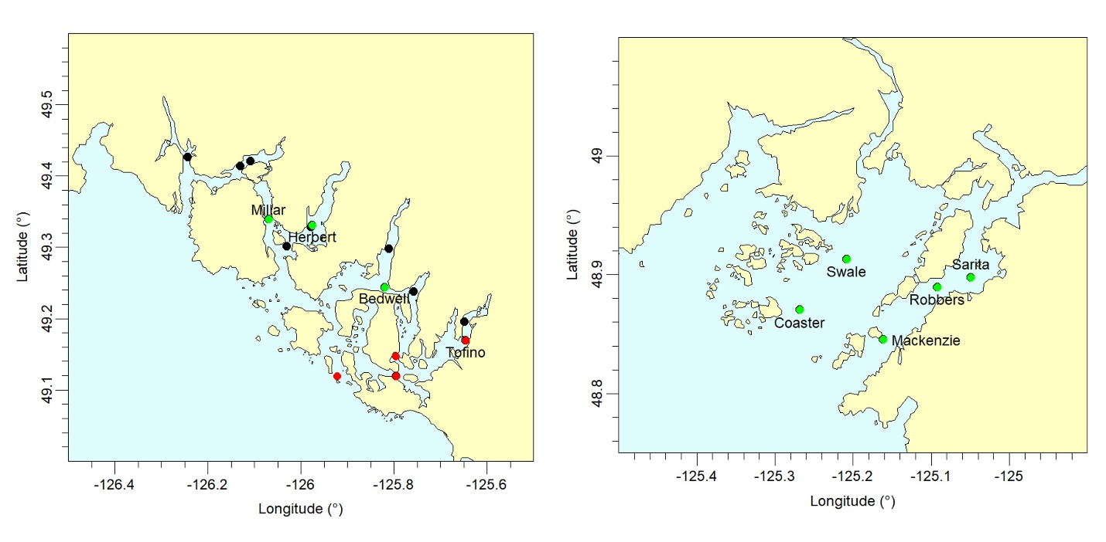
Figure 1. Station map of PSSI plankton monitoring stations in Clayoquot Sound (left) and Barkley
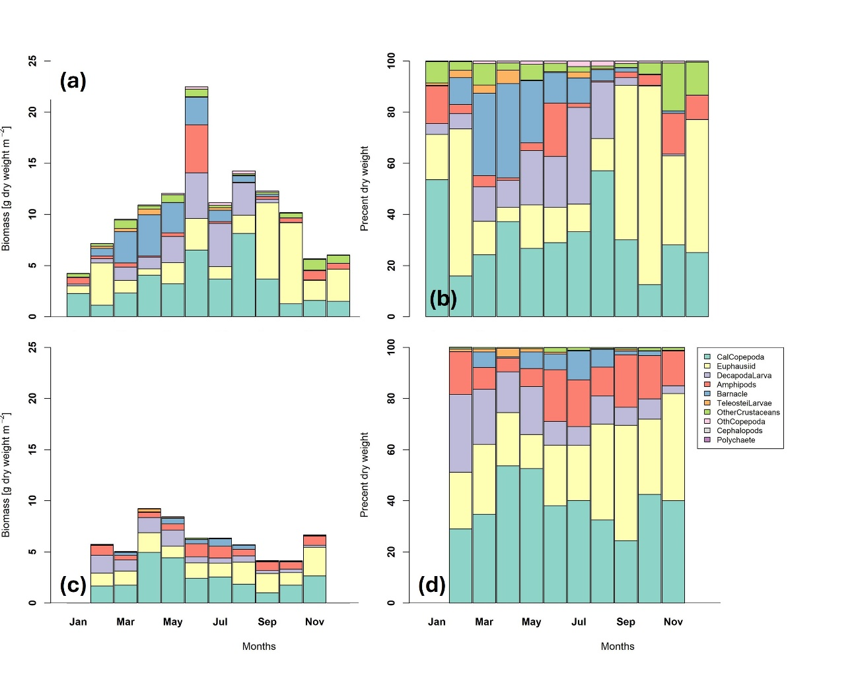
Sound (right). Clayoquot Sound stations were sampled on a monthly basis between 2023-2025 Barkley Sound stations were sampled on a monthly (February to November) basis, 2022-2025 Core sampling stions in Clayoquot Sound identified with green (2023) and red (2025) symbols black symbols identify stations sampled opportunistically.

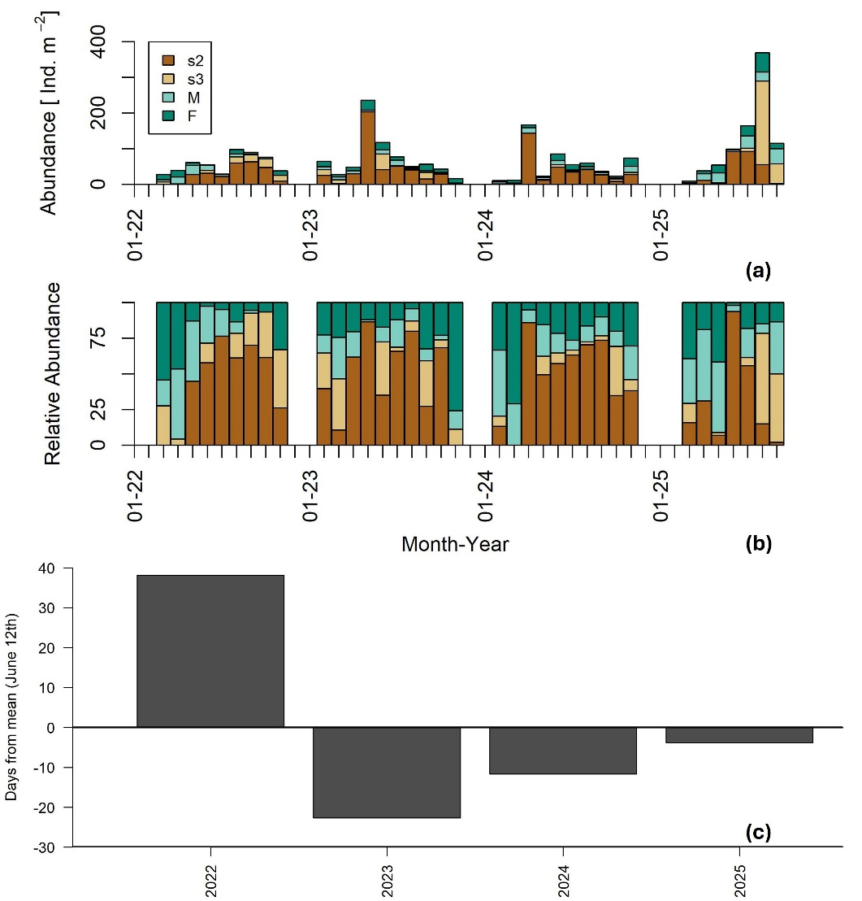
Figure 2. Annual cycle of net zooplankton sampled monthly in Clayoquot Sound (upper panels, 2023-2025) and Barkley Sound (lower panels, 2022-2025), British Columbia. Panels (a) and (c) represent biomass (mg dry weight m⁻²) averaged within month and partitioned by plankton grouping common to local juvenile Chinook stomach contents and the relative division of biomass among these groups is illustrated in panels (b) and (d).

Figure 3. Temporal patterns of the: a) abundance (Number individuals m⁻²) ; b) relative abundance; and c) relative timing of peak abundance of Thysanoessa spinifera Barkley Sound, British Columbia. Stacked bars represent: 5-9 mm juveniles (s2) ;10-15 mm juveniles (s3); adult males (M); and adult females (F).

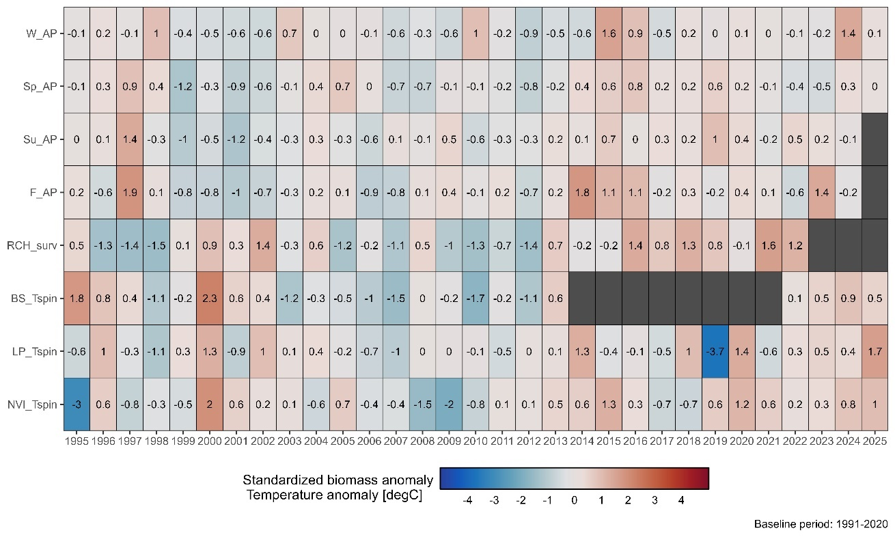
Figure 4. Heatmap of seasonal sea surface temperature anomalies (°C) at Amphitrite Point lighthouse (AP) and standardized annual biomass anomalies for the euphausiid, Thysanoessa spinifera (Tspin) in Barkley Sound (BS), La Perouse banks (LP), and the northern shelf of the West Coast of Vancouver Island (NVI). Standardized time series of estimated survival to age two via Robertson Creek Hatchery (RCH) indicator coded wire tag recoveries (Brown 2024). Biomass and survival anomalies for each time series were standardized to their respective mean. The number of standard deviations from the mean is printed in each box and colour-scaled accordingly. Blue and red shades represent values below and above the climatological mean, respectively.

📈 References
Include full references for any publications referenced in other sections. Please format references in Harvard style according to Instructions to Authors for the Canadian Journal of Fisheries and Aquatic Sciences, at Canadian Science Publishing.
Brown, N. A. W. 2024. West Coast of Vancouver Island Chinook Terminal Return Forecast for 2024. West Coast of Vancouver Island Stock Assessment Bulletins. 16 p.

Feinberg, L.R., and Peterson, W.T. 2003. Variability in duration and intensity of euphausiid spawning off central Oregon, 1996–2001. Progress in Oceanography. 57: 363-379.

Fisher, J.L., Menkel, J., Copeman, L., Shaw, C.T, Feinberg, L.H., and Peterson, W.T. 2020. Comparison of condition metrics and lipid content between Euphausia pacifica and Thysanoessa spinifera in the northern California Current, USA. Progress in Oceanography. 188: 102417. https://doi.org/10.1016/j.pocean.2020.102417

Irvine, J.R., Luedke, W., Pearsall, I., Sastri, A., Carson, C., Menendez, C., Hutchinson, J., Miller-Saunders, K.M., and Hawkins, T. 2024. Marine Risk Assessment for Natural-Origin West
Coast Vancouver Island Chinook Salmon (Oncorhynchus tschawytscha). Can. Tech. Rep.
Fish. Aquat. Sci. 3603: ix + 308 p.

Shaw, C.T., Peterson, W.T. and Sun, S. (Eds.) 2013. Report of Working Group 23 on Comparative Ecology of Krill in Coastal and Oceanic Waters around the Pacific Rim. PICES Sci. Rep. No. 43, 100 pp.

Summers, P.L. 1993. Life history, growth and aging in Thysanoessa spinifera. PhD Thesis, University of Victoria. https://dspace.library.uvic.ca/bitstreams/281fce79-d028-4462-8f0f-092c22c7cc16/download

Tanasichuk, R.W. 1998. Interannual variations in the population biology and productivity of Thysanoessa spinifera in Barkley Sound, Canada, with special reference to the 1992 and 1993 warm ocean years. Marine Ecology Progress Series. 173: 181-195

